**Comprehensive Pandas Visualization**

Pandas stands as one of Python's most influential data manipulation libraries, offering sophisticated visualization capabilities that seamlessly integrate with its powerful data analysis tools. This comprehensive guide explores Pandas' visualization ecosystem in detail, providing extensive examples, advanced techniques, and professional best practices.

**1. Library Overview: The Power of Pandas Visualization**

**Pandas** emerged as a game-changing library for data analysis in Python, and its visualization capabilities represent a perfect marriage between data manipulation and visual storytelling. Built on top of Matplotlib, Pandas plotting provides an intuitive, DataFrame-centric approach to creating charts that eliminates the complexity of traditional plotting workflows.

**Unique Features and Advantages**

**Primary Use Cases in Professional Environments**

**2. Comprehensive Graph Types and Implementation**

**A. Line Plots - Temporal and Sequential Data Visualization**

**Basic Implementation**:

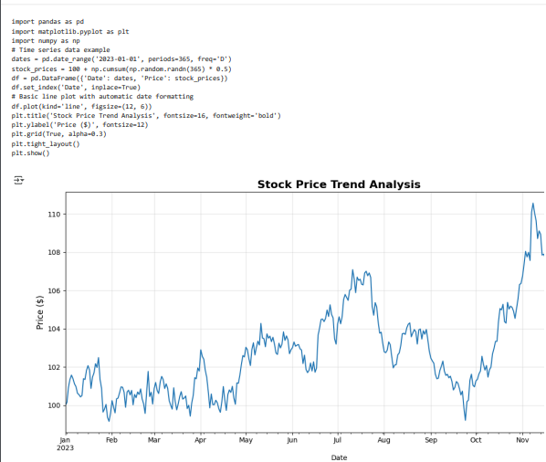

**Advanced Multi-Series Implementation**:

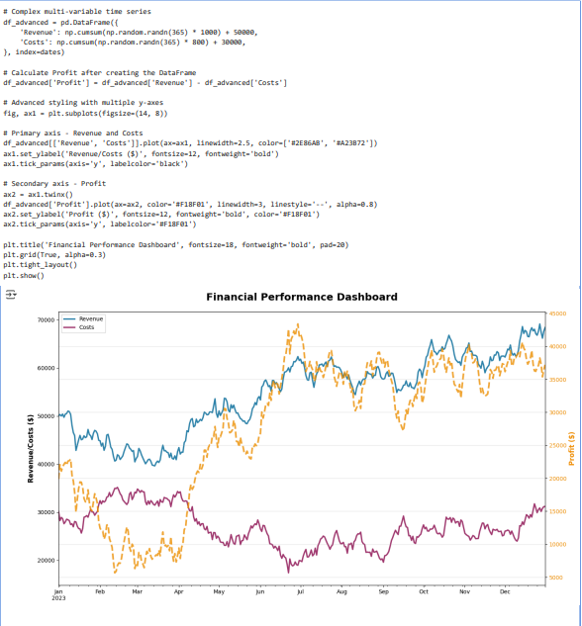



**B. Bar Charts - Categorical Comparison and Ranking**

**Basic Vertical Bar Chart**:

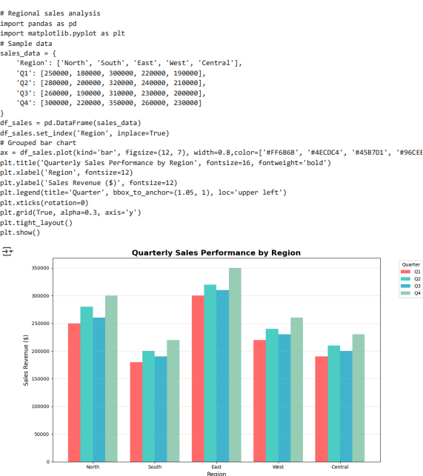

**Advanced Horizontal Bar Chart with Annotations**:

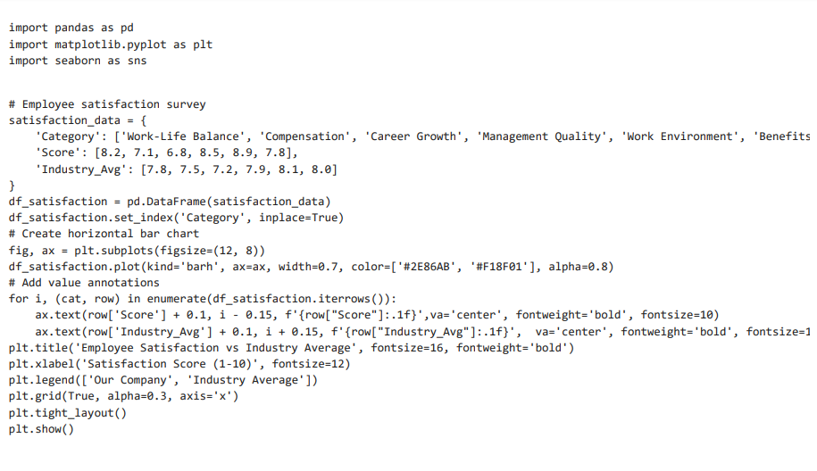

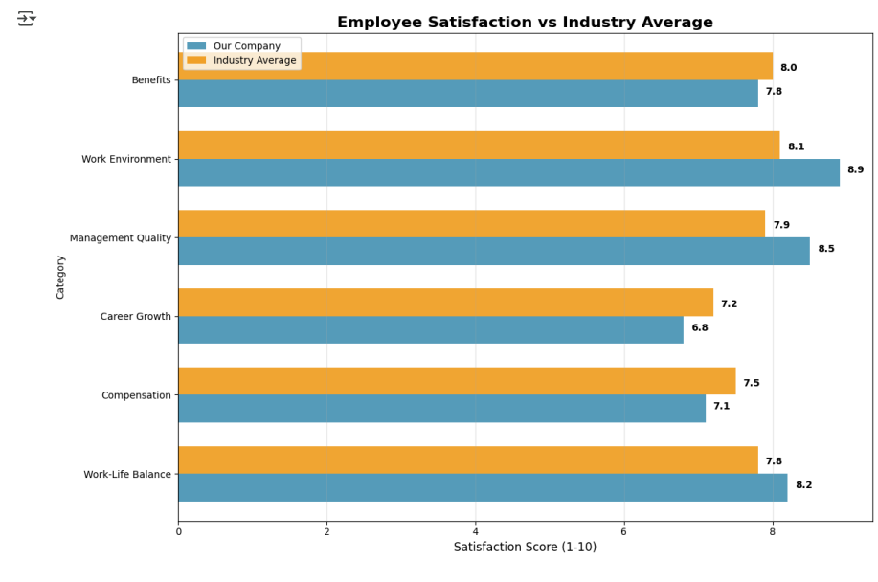

**C. Histograms - Distribution Analysis and Statistical Insights**

**Basic Distribution Analysis**:

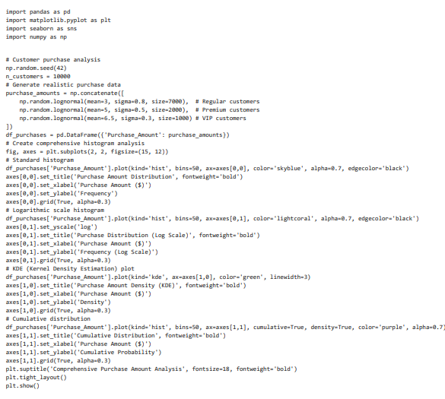



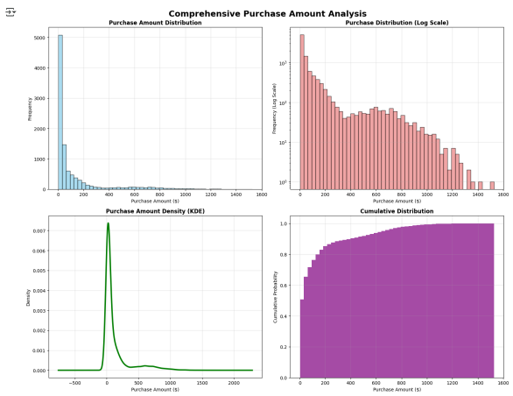

**D. Box Plots - Statistical Distribution and Outlier Detection**

**Comprehensive Multi-Group Analysis**:

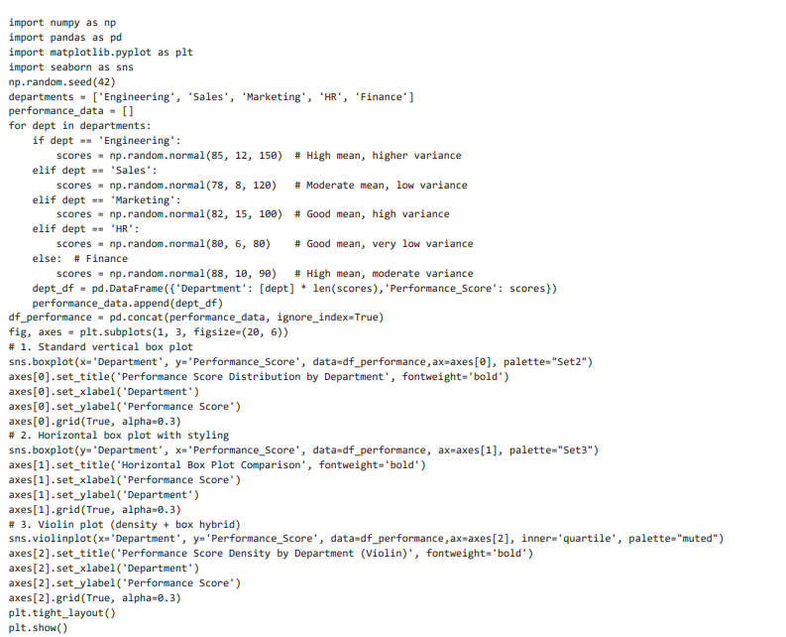

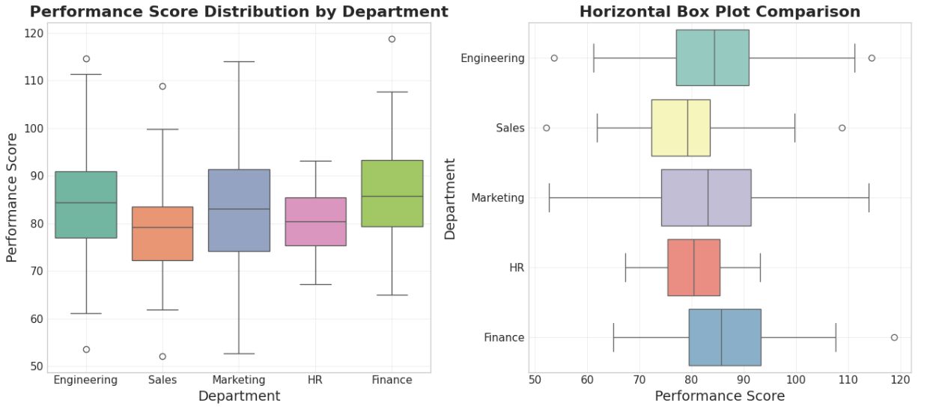 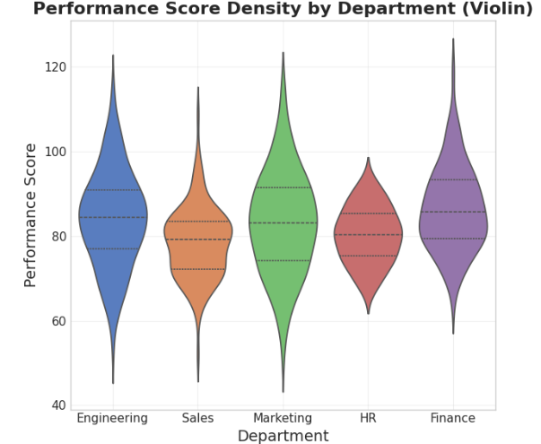

**E. Scatter Plots - Correlation and Relationship Analysis**

* Marketing campaign effectiveness (ad spend vs. revenue)
* HR analytics (experience vs. salary, performance vs. retention)
* Financial analysis (risk vs. return, correlation analysis)
* Scientific research (hypothesis testing, experimental validation)
* Customer segmentation and behavioral analysis

**Advanced Multi-Dimensional Scatter Analysis**:

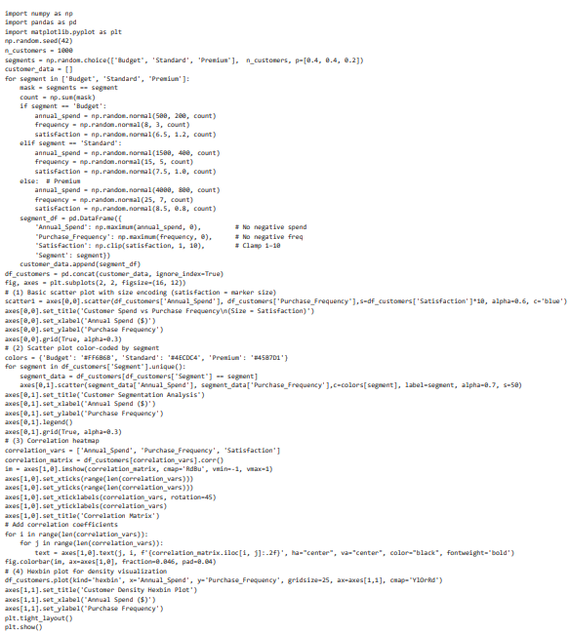

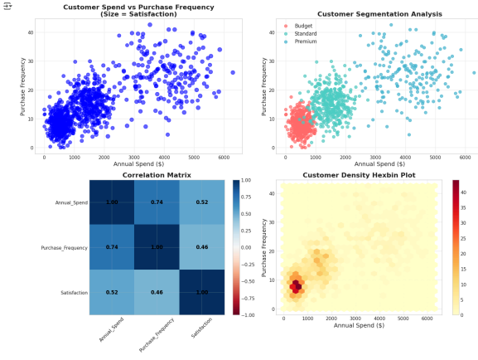

**F. Pie Charts - Proportional Analysis and Composition**

**Advanced Multi-Level Pie Chart Analysis**: 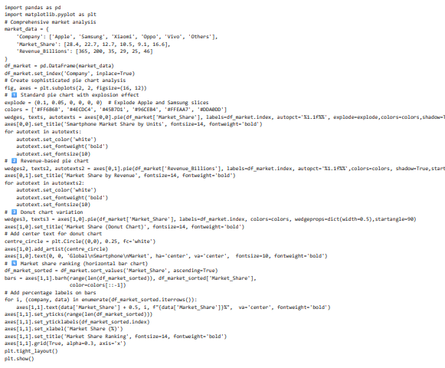

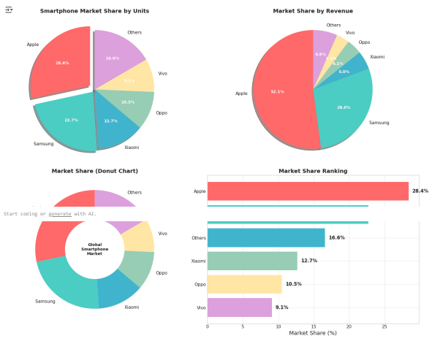

**G. Area Plots - Cumulative Analysis and Stacked Visualization**

**Advanced Stacked Area Analysis**:

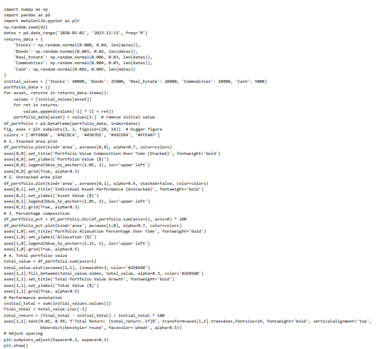

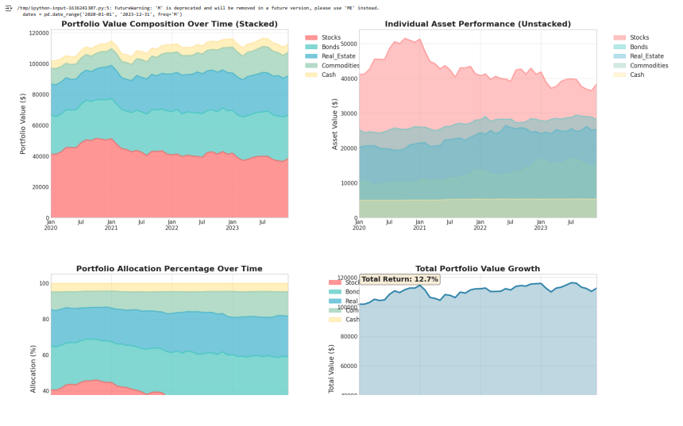

**H. Advanced Plotting Features**

* **KDE (Kernel Density Estimation) Plots**

**Description**: KDE plots provide smooth estimates of probability density functions, offering insights into data distribution shapes without the binning artifacts of histograms.

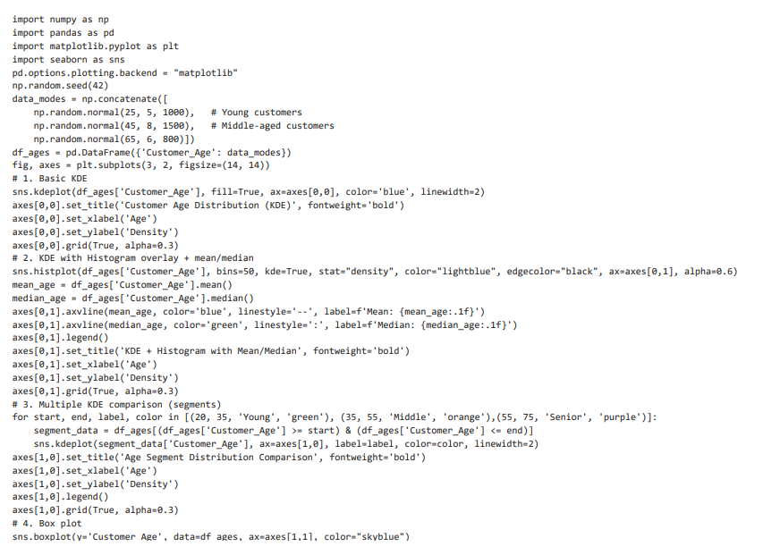

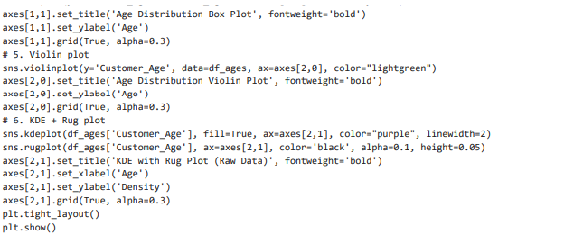

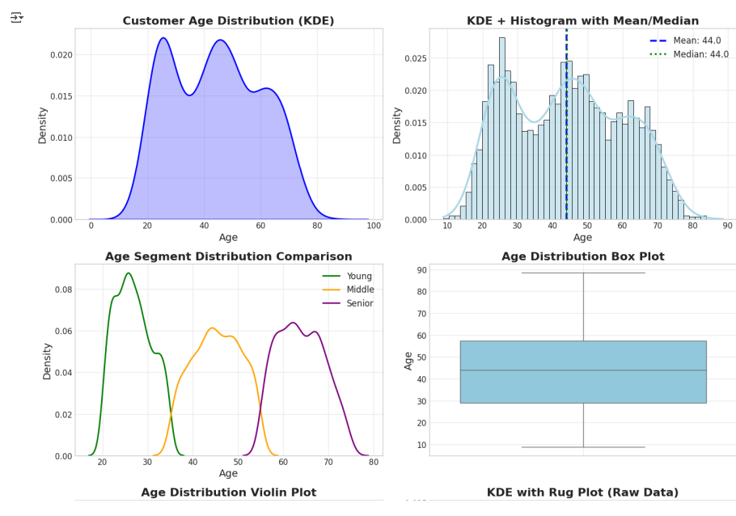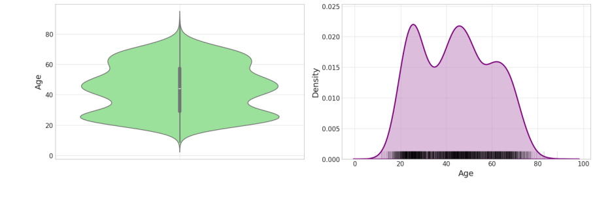

* **Hexbin Plots for Large Datasets**

**Description**: Hexbin plots aggregate large scatter plot data into hexagonal bins, using color intensity to represent point density. They excel at visualizing patterns in massive datasets where traditional scatter plots become overcrowded.

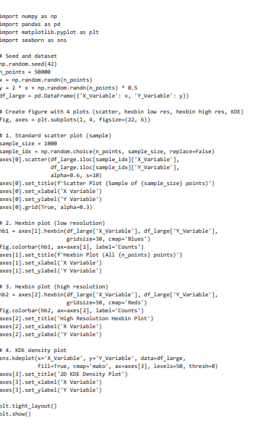



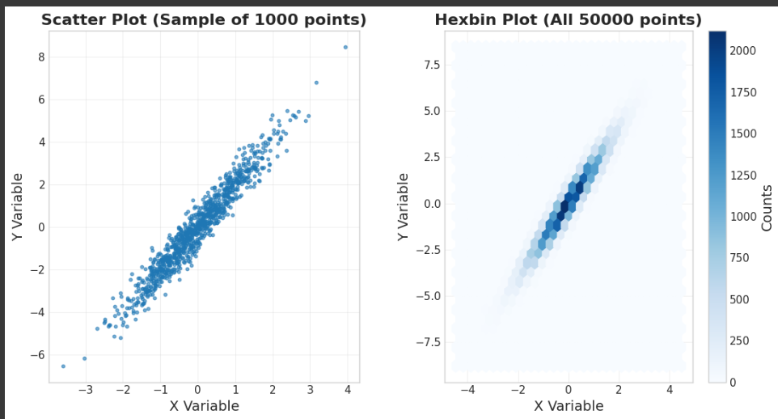

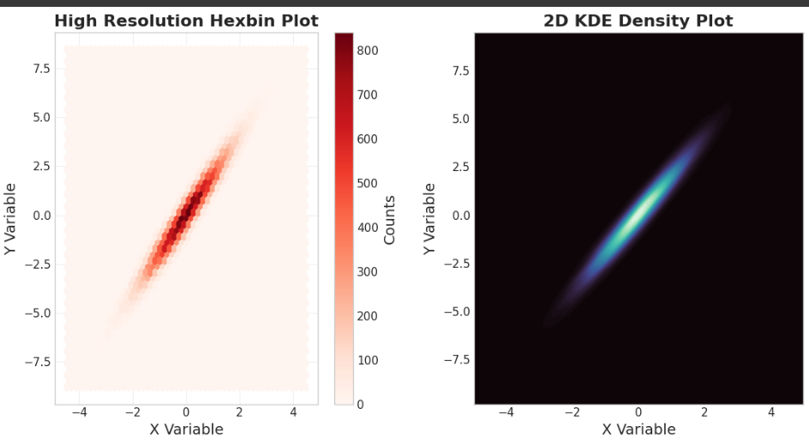

**3. Advanced Customization and Professional Styling** 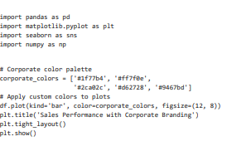

**Global style configuration**

VPandas plotting can be extensively customized using Matplotlib's rcParams system and style sheets

**Custom Color Palettes and Themes**

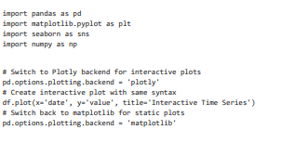

**Multi-Backend Support and Interactive Plotting**

Modern Pandas supports multiple plotting backends for enhanced interactivity

* **Library Comparison: Pandas vs. Other Visualization Libraries**

|  |  |  |  |  |  |
| --- | --- | --- | --- | --- | --- |
| **Feature** | **Pandas** | **Matplotlib** | **Seaborn** | **Plotly** | **Bokeh** |
| **Ease of Use** | ⭐⭐⭐⭐⭐ | ⭐⭐⭐ | ⭐⭐⭐⭐ | ⭐⭐⭐⭐ | ⭐⭐⭐ |
| **Data Integration** | ⭐⭐⭐⭐⭐ | ⭐⭐ | ⭐⭐⭐⭐ | ⭐⭐⭐ | ⭐⭐⭐ |
| **Customization** | ⭐⭐⭐ | ⭐⭐⭐⭐⭐ | ⭐⭐⭐ | ⭐⭐⭐⭐ | ⭐⭐⭐⭐ |
| **Interactivity** | ⭐ (⭐⭐⭐⭐ with backends) | ⭐ | ⭐ | ⭐⭐⭐⭐⭐ | ⭐⭐⭐⭐⭐ |
| **Performance (Large Data)** | ⭐⭐⭐ | ⭐⭐⭐ | ⭐⭐ | ⭐⭐⭐⭐ | ⭐⭐⭐⭐⭐ |
| **Statistical Plots** | ⭐⭐⭐ | ⭐⭐ | ⭐⭐⭐⭐⭐ | ⭐⭐⭐ | ⭐⭐⭐ |
| **Learning Curve** | ⭐⭐⭐⭐⭐ | ⭐⭐ | ⭐⭐⭐⭐ | ⭐⭐⭐ | ⭐⭐ |
| **Documentation** | ⭐⭐⭐⭐ | ⭐⭐⭐⭐⭐ | ⭐⭐⭐⭐ | ⭐⭐⭐⭐ | ⭐⭐⭐⭐ |

* **Detailed Strengths and Weaknesses Analysis**

|  |  |
| --- | --- |
| **Pandas Visualization Strengths**:   * **Seamless DataFrame Integration**: No data extraction or reshaping required * **Rapid Prototyping**: Generate complex plots with minimal code * **Intelligent Defaults**: Automatic handling of indices, column names, and data types * **Multiple Backend Support**: Can leverage Plotly, Bokeh, or other libraries transparently * **Perfect for EDA**: Ideal for exploratory data analysis and quick insigh | **Pandas Visualization Limitations**:   * **Limited Advanced Customization**: Complex styling requires Matplotlib knowledge * **No Native Interactivity**: Static plots unless using alternative backends * **Limited 3D Support**: Basic 3D capabilities compared to specialized libraries * **Statistical Plot Limitations**: Fewer built-in statistical visualizations than Seaborn * **Performance with Very Large Data**: Can struggle with millions of data points |

**5. Best Practices and Professional Guidelines**

* **Code Organization and Reusability**

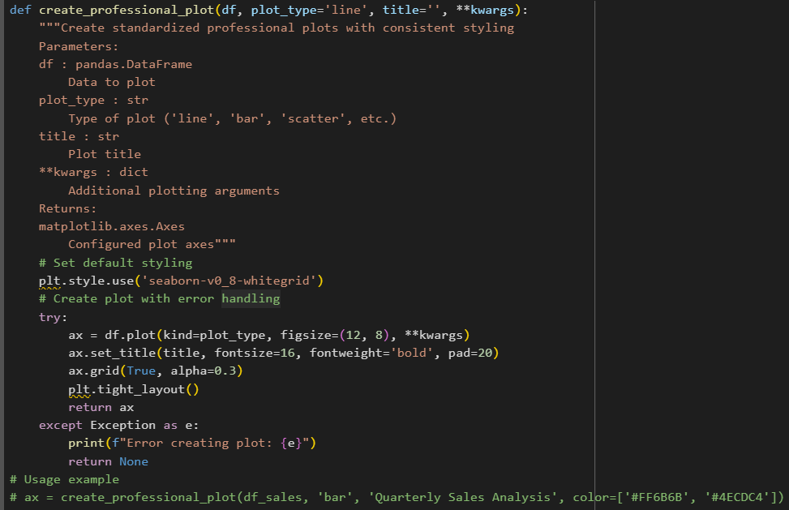

* **Performance Optimization for Large Datasets**

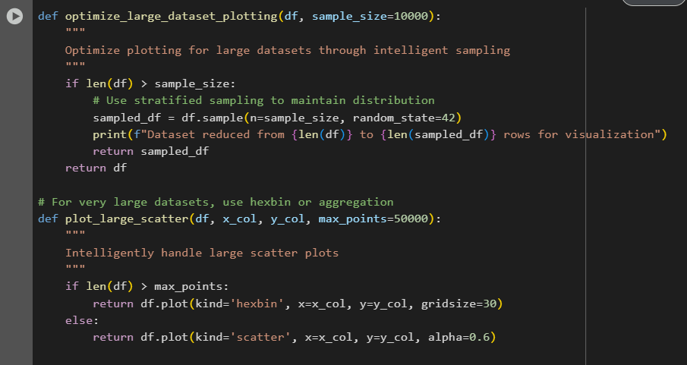

* **Accessibility and Color-Blind Friendly Palettes**

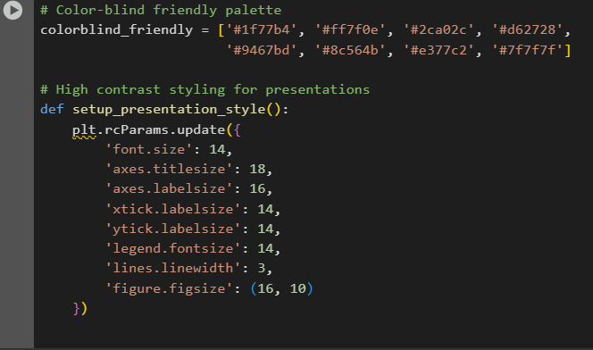

* **Seamless EDA Integration**

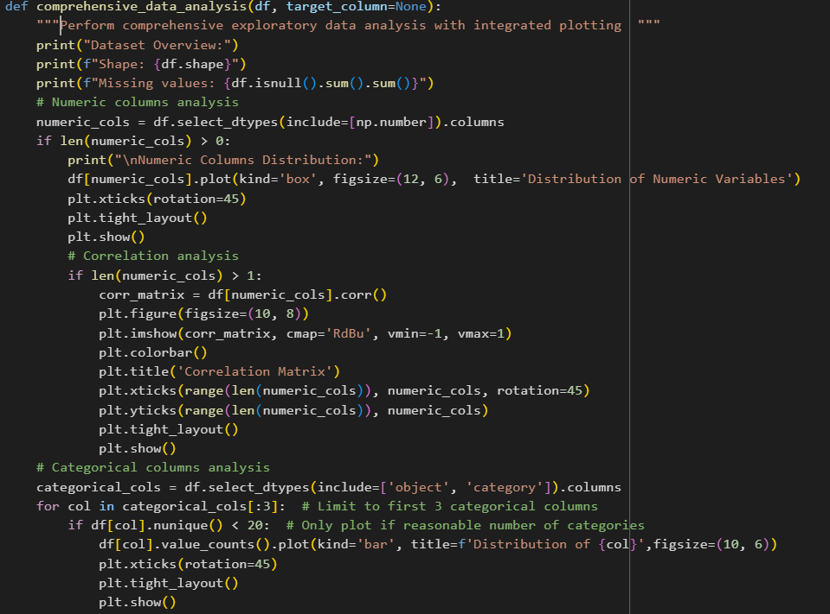

* **Future-Proofing and Modern Practices**

Pandas visualization is built to evolve with the wider Python ecosystem, providing adaptability for changing data science needs. With support for multiple plotting backends—like Matplotlib for static charts and Plotly or Bokeh for interactive web-based visualizations—users can choose the right tool for each context without learning a new API. Backend selection is as simple as a configuration change, ensuring your code remains compatible with the newest technologies and interactive data platforms.

* **Integration with Modern Data Science Stack**

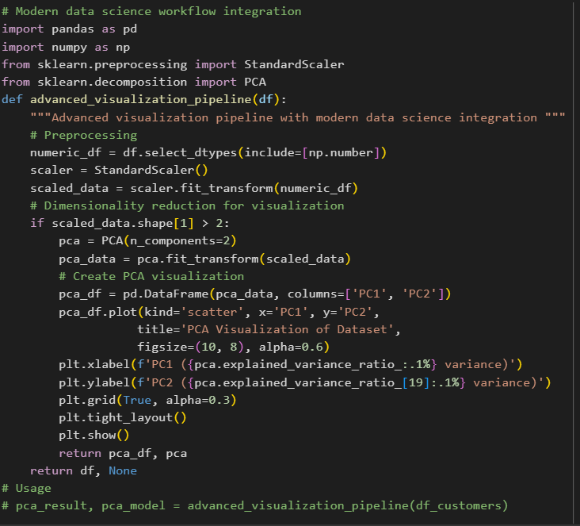

* **Backend Flexibility**

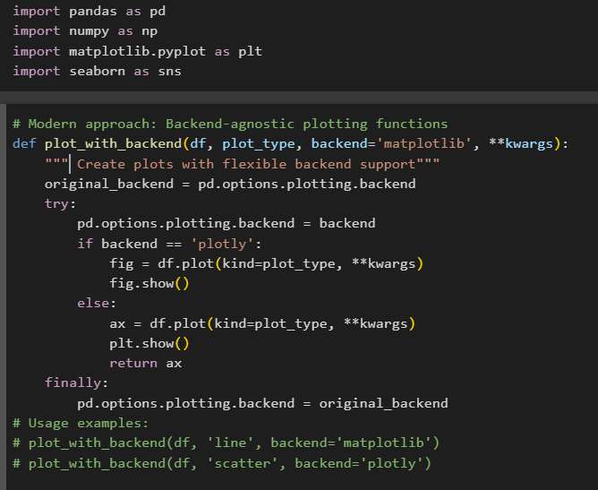

**Conclusion**

Pandas visualization represents the perfect balance between simplicity and power in the Python data science ecosystem. Its tight integration with DataFrame operations, intelligent default behaviors, and growing ecosystem of backends make it an indispensable tool for data analysts, scientists, and business professionals.

**Key Takeaways**:

1. **Rapid Development**: Pandas plotting enables faster iteration from data exploration to insight communication than any other Python visualization approach.
2. **Professional Quality**: With proper styling and customization, Pandas can produce publication-ready visualizations suitable for business reports and scientific papers.
3. **Ecosystem Integration**: The growing support for multiple backends (Plotly, Bokeh, etc.) ensures Pandas plotting will remain relevant as visualization needs evolve.
4. **Learning Investment**: Time invested in mastering Pandas plotting pays dividends across the entire data analysis workflow, from initial exploration to final presentation.
5. **Future-Proof Approach**: The combination of stable core functionality with extensible backend architecture ensures long-term viability and continuous improvement.

Whether you're conducting exploratory data analysis, building business dashboards, or creating scientific visualizations, Pandas plotting provides the foundation for clear, effective, and professional data communication. Master these techniques, and you'll have a powerful toolkit for transforming raw data into compelling visual narratives that drive decisions and create impact.